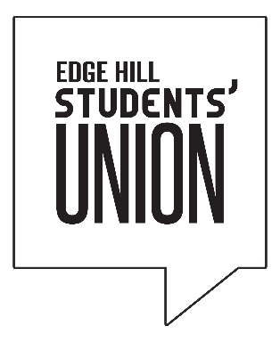

Board of Trustees – Minutes of the meeting held on 30th October 2017
Full Name |  | Position |  | Present | Apologies | Absent
Ben Whittle |  | Sabbatical Officer Trustee - Chair | BW | *
Rosie McKenna |  | Sabbatical Officer Trustee | RM | *
Dan Bocharnikov |  | Sabbatical Officer Trustee | DB | *
Luke Myer |  | Sabbatical Officer Trustee | LM | *
Phil Garner |  | External Trustee | PG | *
Colin Dyas |  | External Trustee | CD |  | *
Joanne Caldwell |  | External Trustee | JC | *
Paul Hodgson |  | External Trustee | PH | *
Christina Donovan |  | Student Trustee | CD |  | *
Richard Raymond |  | Student Trustee | RR | *
Callum Johnston |  | Student Trustee | CJ | *
In Attendance (Non-Voting)
Paul Malone | Chief Executive |  | PM | *
Conrad Jones | Head of Student Engagement |  | CJ | *
Katie Crotty | Head of HR |  | KC | *
Lizzie Orr | Head of Marketing |  | LE |  | *

- Apologies for Absence

Colin Dyas, Christina Donovan and Lizzie Orr

- Chair’s announcements / action

The Chair welcomed Richard Raymond and Callum Johnston to the meeting as our two new student trustees.

- Declarations of Interest

There were no declarations of interest

- Minutes of Previous Meeting

The minutes where accepted as a true and accurate record.

- Minutes of Committees

The minutes of the previous Policy & Campaigns Committee were tabled on the night and were accepted as a true and accurate record.

- Sabbatical Officer Reports

The VP Academic Officer and President both went through their reports briefly. The VP Activities Officer and VP Welfare gave verbal updates regarding their activity between meetings.

- NSS Paper

David Jones, our Policy & Campaigns Manager, delivered a report about the 2017 National Student Survey. Summary points where considered regarding the performance of both the University and Students’ Union.

Now that question 26 has taken on more of an academic theme, the main point made by David was that the Students’ Union now forms part of a University-wide team which looks to improve performance year-on-year and that Faculty Engagement Plans will be developed in order to build stronger relationships with each academic part of the University.

- Report and Financial Statements for the Year ended 31st July 2017

Michael Jayson, Partner at CCW Auditors, presented both the Audit Report and financial statements for year end July 2017. They were approved.

- Management Accounts

The management accounts for September were presented. Whilst it is early in the year, our main concerns fall within the commercial parts of our business, notably labour costs associated with both the bar and catering, and sales in relation to the retail outlet. Income in the bar has improved year-on-year and Subway is performing ahead of budget.

- Chief Executive Report

The CEO provided updates on the following; a new trustees’ handbook which was tabled and presented electronically, the new 2017 Charity Code of Governance, our own internal governance review (final recommendation being made at our December 2017 Board), and the final sign off of the new strategic plan.

- Senior Management Team Reports

The SMT gave updates for their own specific area. To date, operationally we are performing well and in line with the new strategic plan, barring some of the concerns already mentioned about commercial performance. The Board also decided that the format of the SMT report should change in order to refine papers and that from now on, The Board should just receive a CEO report of no more than 10 pages in which all SMT aspects are covered.

